RELEASE1 VALIDATION

Feedbacks - October 26, 2005

A - Questions and precisions related to the Portal UI

- How do we change the images thumbnails in the right side of the header area? Is the system able to select and display randomly them from a set of images (on browser refresh or after a fixed delay)?
- Once logged in, the user can not log out?
- From Zope administration panel the support for Arabic Localization had been setup but the ‘Arabic item does not appears in the language selection list box. How should we perform?
- The Quick Access is a list box of links. The site manager should be able to modify this list of items via Naaya administration panel.
- When a sub-menu from the contextual menu (located in the left porlet section) is selected, all the main menu is expanded ( and all sub-menus are displayed)
- The sitemap UI should be enhanced: please suggest others icons (for the folder, e.g. a water drop), lighten the page when all the folders are expanded, highlight the top folders (e.g. bold font) … Please refer to the functional specifications that describe the navigation for the order of the folders (see sitemap ordering pp. 3-4). The folder information does not exist in the navigation scheme, its content is related to the “About” section. “News” and “Events” should be under “Resources”

B - Questions and precisions related to Functionalities

- How thesaurus are imported and exported? You mention the possibility to import thesauri/glossaries from different sources, how the system is operating the merge?
- How the multilingual search will operate? Will it be cross-lingual (i.e. giving results in other languages based on the thesaurus)? Is it based on terms or on language-independent ID using the multilingual thesauri?
- To categorize, index or search properly every type of objects inside portal but also to assist the visitor to choose its areas of interest for guided search, notification or information pushing (at registration time), we find it suitable to have the keywords and coverage picked and added from the thesaurus. The GUI implemented in NaayaGlossery module is suitable (see picture below). Offering this way to associate keywords to objects greatly help in metadata harmonization and management.

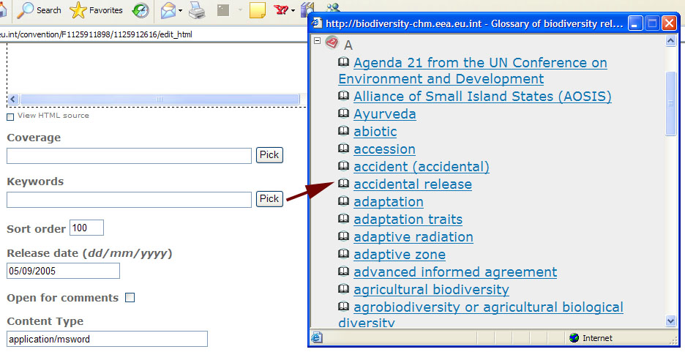

For search, notification and information pushing, it would be nice to have Boolean operators to build a query with the keywords (or an similar result can be obtained in setting up several notification)

- Could you please provides us with detailed technical solution/implementation related to the following features :

  - Notification. For recall: user notification is primary based on thematic topics (20 top level topics of the thesaurus) and on the portal objects (MED EUWI, news, events, documents…). Will Boolean operator be used, e.g. I am interested in “Algeria AND ground water” OR “Algeria and irrigation”
  - Thematic folders (Management? Presentation?)
  - Statistics (Why and how the log files have to be managed?)
  - Newsletters (How the portal content can be aggregate to generate newsletters?)
  - Crawler (which solution?)
  - Access to EMWIS Oracle-based Thematic Directory should be implemented in order to dynamically query and display information inside the portal (Country pages and others). EMWIS will furnish the database schema.
  - Diffusion list ?
  - On-demand Push service?

C - Resources related to EMWIS Metadata and Thesaurus

- The attached file metadata_v2.doc describes the metadata for different namespaces
- Files regarding Thesaurus are located at the address http://www.lirmm.fr/~abrouk/meta/SKOS/
Sitemap ordering

About the Site
Site map
Copyright & Disclaimer
Webmaster
Contact us
FAQ
What’s new?
Statistics
Countries
Introduction
Euro-Med partnership
Mission
Themes
Organization
Activities
Partners
RIOB
IME
GWP
SPONSORS
CEDEX
OIEau
SOGESID
European Commission
Initiatives & Projects
Database
MED EUWI
About Water Initiative
Objectives
Geographical Area
Steps
Documents
Actors
MEDA EAU
About MEDA Water
Objectives
Geographical Area
Projects (list)
Steps
Documents
DCE
About the Water Framework EC
Common strategy
Steps
Objectives
Documents
Legislation
Examples (drop down list)

INCO MED
About INCO MED
Objectives
Geographical Area
Projects (list in a dropdown menu)
Steps
Documents
LIFE
About LIFE
Objectives
Geographical Area
Projects (list in a drop down menu)
Steps
Documents
SMAP
About SMAP
Objectives
Geographical Area
Projects (list in a drop down menu)
Steps
Documents

EMWIS resources
News
Forums
Agenda
Thematic directory
Search

EMWIS publications
eFlash
Newsletter
Leaflet
Communication plan
Press Corner
Press releases
References
Specialized Press

Documents
Key documents
European legislation
International conventions
International norms
Database
Glossaries
Thesaurus

